

Several years ago, I took a sabbatical. The question that prompted me towards this sabbatical was: I wonder if God ever got tired or gets tired from all of God’s work? Scripture would respond: Yes.

In the gospels, we read about Jesus often retiring to quiet places in order to pray, rejuvenate and rest from all his work of teaching, preaching, healing, blessing and feeding people. In Genesis, we find that in the beginning God rested after the work of creation:

1 Thus the heavens and the earth were finished and all their multitude. 2 On the sixth day God finished the work that he had done, and he rested on the seventh day from all the work that he had done. 3 So God blessed the seventh day and hallowed it, because on it God rested from all the work that he had done in creation. (Gen. 2:1-2)

What a great teaching from scripture for us! God rested! God built rest/sabbath into creation itself as a natural part of health, vitality and life. Jesus embodied this in his earthly, human life, again revealing to us and for us that rest is holy, good and necessary.

Sabbath rest is a gift to us, a word of grace built into life by God. Too often we overlook, dismiss or squander this gift of grace. Somehow coming to believe instead that all our value, life, health and vitality is rooted in endless producing, doing, consuming, staying busy.

But this is not so. God knows we need sabbath. So my mission challenge to you this summer is: Rest dear people of God. Rest when you need it. Don’t feel guilty. Don’t be pressured by messages that tell you to get busier.

Take a sabbath when you need it. This may take a different form for different people, but what is common is like Jesus — finding quiet moments, times and places to pray, rejuvenate and rest from all your work and to give thanks to God for essentially teaching us in scripture— It’s ok to take a break from all the work.

I pray you have blessed times of rest and rejuvenation this summer!
— Pastor Kara

Pastor Kara will be on Sabbath/vacation from June 29 - July 12.
For Pastoral Care emergencies please call Rachel King
724-454-6476 and she will contact the pastor on call.
See the calendar in the Newsletter for the Worship Supply Schedule..



First Trimester Financial Report
Income
A summary of our financial wellbeing as of the beginning of May: we are in fair shape. Compared to last year, envelope income is slightly higher. At this time last year our income from envelopes was $63,939, this year it is $67,564, an increase of $3625. However one giving unit who usually gave a large donation at the

end of year has given early which inflated this number so the increase is only $625. Of the 75 other giving units that contributed so far this year, 44 units have given more than last year, 19 have given less, and 12 gave the same. There are 11 units who contributed last year during the first trimester that have not contributed so far this year. Of these one has died, two have transferred and the other eight have not contributed for various reasons.

To compare with budgeted income, the first trimester budgeted amount is $49,566, which makes it appear like we are significantly ahead of budget but it includes four contributions that is their donation for the year. If these contributions are distributed into the trimesters we are only $1998 ahead of the budget with summer coming.

Expenditures
We have spent more on snow removal than budgeted and more on gas than what we anticipated. We need a warm November and December. The repair of the auxiliary heat/cooling unit cost over $2000 of unbudgeted expenses (it will be taken out of Major Repair escrow account for now). Card tables were purchased but paid for by contributions. Some major anticipated expenses include sealing and painting the main parking lot, replacing lighting in the social room (We are applying for a grant to cover material but labor will not be covered), and repointing the bricks on outside of church near the rock garden at entrance. Donations to these projects can be made to major repair. Remember however we need regular give to meet budget expenses and save tapping our operating escrow to make budget.

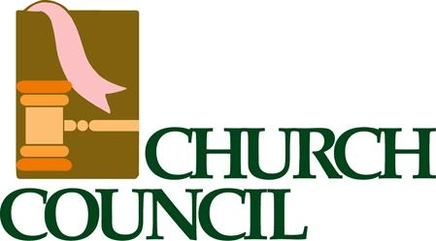

Good Shepherd Lutheran Church
Church Council Meeting Highlights
May 18, 2026
12 In Attendance | 12 Decisions | 7 Motions Passed
Key Decisions
• Communion Practices/ Altar Guild
→ Pour the minimum amount of wine. Unused wine can be used from Saturday to Sunday. Intinction will not be instituted on Saturday night.
• Lighting System-Social Room
→ Social room is the priority and then the Preschool.
• Broadcast License
→ Tabled until next month pending determination of what fund would cover the associated license fees.
• Handicap Parking Spots, Shingle Repair
→ Decision to seal the parking lots depends on quotes received.
May eventually need to research grants for roof replacement. A suggestion was made that a metal roof might be cheaper.
• ⚡ Progress of Direct Deposit for employees
→ Going to proceed with instituting direct deposit but will take at least another month, hopefully will begin in July.
• Synod Assembly
→ Good Shepherd can send two voting members to the Synod Assembly on June 12th and 13th.
• New Members
Jean Hippler
Deb Mickey
Bailey's- Kendra, Erik, Faren & Isla
→ To accept Jean Hippler, Deb Mickey, and the Bailey family, including Eric, Kendra, Faren and Isla, as members of Good Shepherd Lutheran Church.
Motions
• To accept Eric, Kendra, Faren and Isla Bailey, as well as Jean Hippler and Deb M... (Passed unanimously)

• Vacant Council Position
→ Barb would fill Dee's remaining term for 2026 and then be able to run again for a full term in January 2026.
Motions
• To accept the resignation from church council submitted by Dee Salentino. (Passed unanimously)
• To nominate Barb Terek to replace Dee Salentino on church council. This will be ... (Passed unanimously)
• ⚡ Barb presented invoices received for work done by Donahue's Heating and Cooling and for recently purchased card tables. Also included were flowers and the changes to the Pastor's office door. Property escrow showing as over budget.
→ The net cost after contributions/sales is $109.16. RHP to reimburse the church for the sink.
• ⚡ Linda presented a document from years ago showing non-profit status for the Rocking Horse Preschool.
→ Need to secure a new copy of the document to show that Rocking Horse Preschool continues to remain non-profit.
• ⚡ New Council Meeting Minutes Process
→ Council members who have an email will be able to submit their committee reports on the program created by Andy beginning next month.
• ⚡ Frequency of newsletter
→ Pastor Kara indicated that the newsletter would not be generated until after the Parish Council Meeting next Tuesday and that it would contain the same information as an August newsletter. Rachel is to be on vacation beginning mid-July so if any new information was to be included a substitute would have to generate the newsletter.
Motions
• Good Shepherd is to generate and send an August newsletter. (Passed)
Action Items
• Lighting System-Social Room
→ Pending the outcome of the grant application to Scott Electric Foundation.
• Broadcast License
→ Greg Bittner: To determine funding source for licensing fees. (Due 06/15)
• Handicap Parking Spots, Shingle Repair
→ Kathy Wolfe: Pending the receipt of quotes for sealing the parking lots.
Council previously discussed how many handicapped spaces the lot should have. Kathy to look back on prior council minutes to determine.
No action required on the roof at this time. (Due 06/15)
• Progress of Direct Deposit for employees
→ Any ongoing action to be taken by the Treasurer.
• Synod Assembly
→ Anyone interested should contact Brian or Pastor Kara.
• New Members
Jean Hippler
Deb Mickey
Bailey's- Kendra, Erik, Faren & Isla
→ To welcome the above new members to Good Shepherd Lutheran Church.
Motions
• To accept Eric, Kendra, Faren and Isla Bailey, as well as Jean Hippler and Deb M... (Passed unanimously)

• Vacant Council Position
→ See motion.
Motions
• To accept the resignation from church council submitted by Dee Salentino. (Passed unanimously)
• To nominate Barb Terek to replace Dee Salentino on church council. This will be ... (Passed unanimously)
• Barb presented invoices received for work done by Donahue's Heating and Cooling and for recently purchased card tables. Also included were flowers and the changes to the Pastor's office door. Property escrow showing as over budget.
→ No action to be taken at this time.
• Linda presented a document from years ago showing non-profit status for the Rocking Horse Preschool.
→ Kathy Wolfe: Contact Rachel to see if there is an updated document showing RHP as a non-profit. (Due 06/15)
• New Council Meeting Minutes Process
→ Council members to submit their committee reports for the next council meeting using Andy's program. Would be advantageous for all reports to be submitted by June 9, 2026. (Due 06/09)
• Frequency of newsletter
→ After the discussion a motion was presented and voted on and an August newsletter is to be sent. (Due 08/01)
Motions
• Good Shepherd is to generate and send an August newsletter. (Passed)

Officer Reports
• Minutes — Approved
→ April minutes approved as presented with an update. Jenny is no longer pursuing hymn boards since council was reluctant to support without knowing who would update the boards on a weekly basis.
Motions
• To Accept Minutes Report As Presented With An Update. (Passed unanimously)

• Pastor — Approved
→ Pastor's report for April accepted as presented.
• Treasurer — Approved
→ April Budget Report accepted as presented.
Motions
• To Accept Treasurer Report As Presented (Passed unanimously)



The office will be closed on the following dates while I am on vacation.
July
20th, 21st, 23rd, 27th, 28th & 30th



Jimmy & Nino Sunseri Monster & Atomic Pepperoni Rolls. If you placed an order pick up will be June 12th.
Save the Date! Tentative Lock In at Good Shepherd Friday, June 26th
Looking into possibility of Pirate Game, Gettysburg Overnighter as well as an Evergreen Drive In Night.
**Don’t want to miss out on events & interested in joining the youth group!?**
Contact: Rachel King 724-454-6476

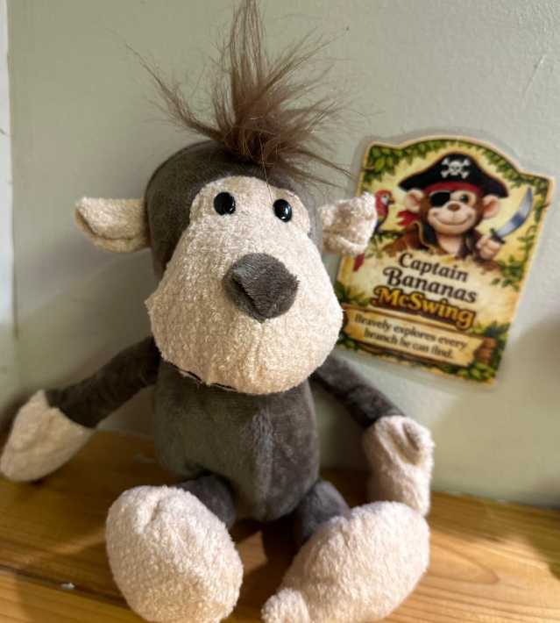


Adopt a MONKEY
from the display case for a $30 donation! All money will go towards this years Vacation Bible School. If not interested in adopting a monkey you can take Dottie (Ocelot) or Tia (Anteater) off the wall located in the Commons Area and donate amount indicated on them by placing it in the offering plate or office with cash or check attached.



Dottie Tia


Save the Date!
Sunday, August 16th during 11:00am service there will be a back-to-school blessing!



Sunday School will resume September 13th @ 9:45AM
Community Fellowship Upcoming Events
June 22-25th

June 13th –
Community Yard Sale
Food for purchase in Social Room/Set up a table for $10.00 and sell your items!

July 15th 6:00-8:00PM –
Christmas in July
More information to come


September 12th 11:00-1:00PM-
Chicken BBQ
Cost- $15.00

October 16th 6:30-8:30PM –
Trunk or Treat
More information to come


December 4th 6:00-8:30PM-
Light Up Night
More information to come

(*All activities are tentative & subject to change*)


www.goodshepherdgbg.org

BLANKET SUNDAY - MAY 12, 2024
Mothers’ Day weekend this year is May 11th and May 12
th
, and once again Good Shepherd
Church members are invited to participate in a collection to fund the acquisition and distribution
of blankets and other disaster relief items to people in need. For the small sum of $10.00 you
can give a blanket to help victims of earthquakes, storms, fires, or the ravages of war. Please use
the Blanket Sunday envelopes provided with your weekly bulletin or in the commons area to
make your donation in honor of or in memory of a mother, grandmother or other special woman
this Mothers' Day.
BLANKET SUNDAY - MAY 12, 2024
Mothers’ Day weekend this year is May 11th and May 12
th
, and once again Good Shepherd
Church members are invited to participate in a collection to fund the acquisition and distribution
of blankets and other disaster relief items to people in need. For the small sum of $10.00 you
can give a blanket to help victims of earthquakes, storms, fires, or the ravages of war. Please use
the Blanket Sunday envelopes provided with your weekly bulletin or in the commons area to
make your donation in honor of or in memory of a mother, grandmother or other special woman
this Mothers' Day.
BLANKET SUNDAY - MAY 12, 2024
Mothers’ Day weekend this year is May 11th and May 12
th
, and once again Good Shepherd
Church members are invited to participate in a collection to fund the acquisition and distribution
of blankets and other disaster relief items to people in need. For the small sum of $10.00 you
can give a blanket to help victims of earthquakes, storms, fires, or the ravages of war. Please use
the Blanket Sunday envelopes provided with your weekly bulletin or in the commons area to
make your donation in honor of or in memory of a mother, grandmother or other special woman
thi



Find the cross (+)
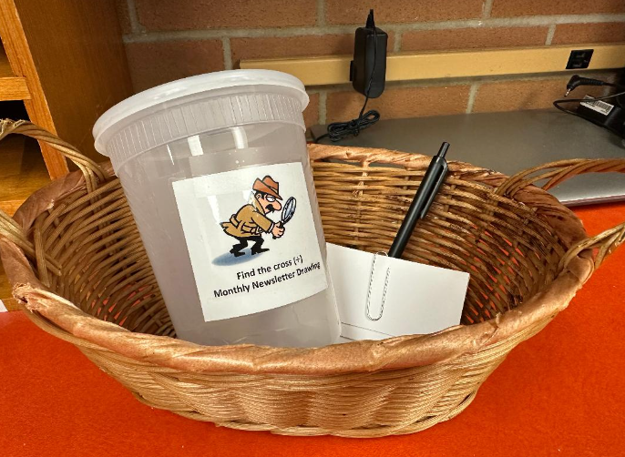
In each monthly Newsletter there will be a hidden cross (+) that can be found in one of the articles! If you find, please turn in where it was found including page # and article found in with your name & number on a piece of paper. At the end of each month, all who turn in will be entered into a monthly drawing to win a prize!
In order to be entered your slip must be turned into office into container labeled Find the cross by the

3rd Sunday of the month.
**This newsletter contains 2 hidden crosses (+) find both for a chance to win!**

Congratulations to our May winner
Mark Gesalman

*The cross was located on page 16

SUMMER WINNER WILL BE ANNOUNCED IN SEPTEMBER NEWSLETTER!

Church Worship & Picnic

Sunday, August 23, 10:30AM
Lund Pavilion, Mount Odin

The annual church picnic will be held at Mount Odin again this year. Last year’s picnic was very successful and attended by over 70 people. This year the picnic has been expanded into a joint Parish Worship Service and Picnic for both congregations. The Parish Ministry Council and members of Good Shepherd and Salem will plan the worship/picnic event.

The event is free, but we ask you to get a ticket so we know how many adult, youth and children will be attending in order to prepare accordingly. Bring your ticket to the event. The tickets will be used to draw for door prizes, valued between $10-$20. This year there will no gag gifts. Tickets will be available starting July 25.

We are asking you to bring a picnic side, such as vegetable, starch, salad, or dessert to share. The parish is providing hamburgers, hot dogs, buns, condiments and beverages. It is also suggested to bring a a lawn chair for your comfort. The pavilion and restrooms are both handicap accessible.

We will start with outdoor worship in the pavilion at 10:30am. (Please note this will be the only worship service that weekend for both congregations. No Saturday or Sunday worship will be held in either church.) Eating will begin after worship. This will be followed by games and activities for both adults and children. Plus plenty of time to just sit around and talk! A large playground is adjacent to the pavilion.

The planning team will meet in June and August. Everyone is invited to help with the planning. If you wish to help in the planning, please contact Jack Gesalman ASAP at (724)-837-7556.

Parish Council
Jack Gesalman & Fellowship Committee



Women’s Summer Bible Study at Zion’s Lutheran Church Greensburg:
All women are welcome to come to any or all of the sessions. No reservations necessary. If you can, bring your Bible & a copy of Gather Magazine. However, if you do not, you may borrow a bible and copies of the bible study pages from the magazine will be provided. The theme this summer is “I am worthy”. It is designed to help us define who we are, what we can be, and what we do in the world, in light of our God-given giftedness, identities, and relationships. Zion’s address is 140 S. Pennsylvania Ave. and they ask that you enter thru the side door on Second Ave. There is only one small step into the air conditioned social hall. The doors will open at 5:30pm for light refreshments and fellowship. Each bible study will begin at 6:00 and conclude by 7:00 to give people the chance to get home while there is still daylight. We hope you will join us, even bring a friend.
Session 1) Wednesday, June 10th
Session 2) Wednesday, July 8th
Session 3) Wednesday, August 12th
Zion’s Women of the ELCA are collecting an offering this year, “$Change$ for a Change” to support this year’s designated outreach, reagan’s journey. Therefore, if you are able, bring along some loose change for the piggy bank. We appreciate it and look forward to seeing you there!

SWPA Women of the ELCA Designated Outreach 2026: reagan’s journey.
Started in 2012, reagan’s journey is a free pediatric closet where families, caregivers, agencies, and hospitals can help children get medical equipment they desperately needed without waiting upwards of 6 months navigating through insurance denials and appointment wait times. Custom equipment is best, but no child should have to wait and insurance will only cover 1 piece of equipment every 3-5 years and as we know children are constantly growing! Reagan's Journey accepts gently used pediatric durable medical equipment and unused medical supplies. The items are sanitized and redistributed to children in need. If you or someone you know would like to donate gently used pediatric medical equipment, please contact them to see if they are able to accept it at this time and to arrange a drop off appointment. Their phone number is 724-826-0778, their email address is info@reagansjourney.org and their website is reagansjourney.org. Anyone who is caring for a child with special needs and is willing to make the trip can schedule an appointment to have access to pick out items they are in need of. On average, they serve 500 families per year by giving them the supplies they need for their kids - for FREE! We are asked to help with monetary donations, their greatest need. It costs $150 per family to operate the Reagan’s Journey Closet. Financial support keeps the pediatric medical equipment closet FREE to families who need it.
Please make checks Payable to: SWPA Women of the ELCA
Write on the designation line: Reagan’s Journey
Mail checks to: Janet Fishovitz 136 Clearwater Drive Ellwood City, PA 16117.
Reagan’s Journey is also excepting $25 Gift Cards for Amazon, Walmart and Sheetz. If you drop gift cards in the church office please mark them what they are for and they will be delivered at the Lutherlyn Fall Retreat. Thank you for your donations.

A Theater Outing for Everyone to enjoy!

Men, Women, Children, Families and Friends are welcome to join us Sunday afternoon July 12th. We’ll meet at Sharkey’s Café in Latrobe around 12:15. We will have reserved tables but everyone will be responsible to pay for your own meal and please tip your server(s). Afterwards, we will head over to Saint Vincent College for their 2:00 feel-good, jukebox musical matinee created by Ted Swindley featuring 30 classic country hits. The show follows three women—a Texas housewife, a sassy Southerner, and a career-driven "citified" girl—meet on a Greyhound bus to + Nashville and pursue stardom in Nashville. It is packed with tunes from Dolly Parton, Loretta Lynn, and Tammy Wynette featuring hit songs including, "Stand By Your Man," "9 to 5," "Coal Miner's Daughter," "Delta Dawn," and "These Boots Are Made for Walking". Tickets are $27. We are working on getting group rates for the show, so hopefully that price will be a little lower. Watch for the sign up sheet with additional details by the water fountain at Good Shepherd. Car pooling will be available. Deadline to sign up is Sunday, June 31st. Contact Karen Gesalman at 724-309-2667 for details and/or reservations.


2026 Triennial Gathering “I Am Worthy” July 16-19, 2026
Des Moines, IA Registration is open.
Go to the following website:
https://www.womenoftheelca.org/new-triennial-event-page to see the lineup of speakers and workshop leaders. Our very own Rev. DaMisha McFarland-Pollock will be a chaplain at the event. There is also links there to register to attend. Registrations are transferable to other people if you decide not to go. If you have any questions, please contact Donna Petrell or Jennifer Armstrong-Schaefer. We hope that you will consider attending the triennial gathering as they are a life-changing event.


2026 Joint Retreat SW & NW PA at Camp Lutherlyn “Stop, Listen, Hear” September 25-27, 2026 Our theme Bible verse is Mark 4:23 “If you have ears to hear, then hear!” (nrsvue). It’s going to be an incredible weekend filled with faith, fellowship, and fun as we take time to slow down, listen for God’s voice, and truly hear His message. Grants are available to help with the expense of camp See Karen for the proper forms if you are interested. The Retreat Committee is still looking for a few more people to join them and help make this year’s retreat amazing! If you’d like to be part of the planning team, please contact either Angeline Schaefer at 724-787-5235 or Donna Petrell at 742-457-9662. We can’t wait to gather together and see everyone at Camp Lutherlyn this September!

If you have any questions about any of the Women of the ELCA activities, please contact Karen Gesalman at 724-309-266

ATTENTION MEALS ON WHEELS
COOKIE BAKERS

Homemade or Store Bought are welcome! Please drop your cookies off AT THE CHURCH.

JUNE
COOKIE BAKERS (GROUP 2) Cookie Sunday is June 14, 2026.
Pat Gatons | Lucy Mento
Darlene Frederickson | Carol Clawson
Ellen Monnich | Susan Rhome

JULY
COOKIE BAKERS (GROUP 3) Cookie Sunday is July 12, 2026.
Doris Wood | Jill Hixson
Dorothy Gesalman | Dixie Mowl
Karen Gesalman | Carol Clawson
We are still collecting cookies for Meals-on-Wheels. At 180 meals per day, 5 days a week, we get enough cookies for about 2 days.
New contributors are always welcome.



The Food Pantry is in need of a restock! All donations greatly appreciated!
Cereal, Pancakes, Syrup, Pasta, Pasta Sauce, Alfredo Sauce, Soup, Canned Meat, Powdered Milk, Fruit, Soup Etc..





 !"#$

%&'()*+,-.**%%
%%)%!/
%%$0(*12
13*0(*1
4%5+6%%
6789
.:;( 
Tri-City Meals on Wheels needs volunteers!
Volunteering is a great way to give back and connect with your community. Tri-City Meals on Wheels, located at 716 Foster Street in Greensburg, is looking for volunteers. Tri-City Meals on Wheels, which receives no government assistance, provides low cost ($3.50/day) nutritious meals to close to 200 people daily, who need the help. Meals are provided 5 days per week, Mon-Fri, excluding holidays and snow days. Volunteers, who prepare food, start at 7:30 AM and are finished around 11AM. Drivers and runners deliver the meals between 10:30 AM to noon. You may have a permanent job/shift per week + or act as a temporary volunteer, covering a shift when someone needs a day off. Interested? Call Tri-City Meals on Wheels a 724 -837-6117.

Happy Birthday to:


June

Kimberly Barnard | (06/02)
Matt Fisher | (06/05)
Bradley Hefflefinger | (06/05)
Kaleb Askey | (06/06)
Ariel King | (06/06)
Harry Harbaugh | (06/07)
Tami Stewart | (06/07)
Jocelyn Askey | (06/08)
Allison Dematt | (06/08)
Mackenzie Mull | (06/10)
Jill Hixson | (06/12)
Linda Harbaugh | (06/16)
Ralph III Demi | (06/22)
Scott McMahan | (06/26)
Lindsey Sullenberger | (06/26)
George Billig | (06/29)
Lynda Gesalman | (06/29)

Happy Birthday to:

July

Giovanna Jones | (07/01)
Carson Hawes | (07/05)
Deborah Fredo | (07/07)
Rachel King | (07/18)
Gemma Huth | (07/19)
Kathrine Wolfe | (07/20)
Jeff Maloy | (07/22)
Mia Reinhart | (07/24)
Sonja Kubinec | (07/25)
Roberta Musiak | (07/26)
Elaine McIntire | (07/27)
Alexa Donoughe | (07/28)
Neil Sullenberger | (07/28)

(If we have missed your birthday, we do not have it in our records. Please help us update them. Thank you)





PRAYER LIST - Our thoughts and prayers are with the following:

Good Shepherd Members:
Tony Mariani
Jackie Guhl
Jane Elliott
Val Pollock
Erik Williams
Mac McMurtrie
Jerry Plummer
John Strasser
Chuck Ober
Kay Wright
Joy Stynchula
Vincent Smith

Friends and relatives of the Good Shepherd family:

Lauren Floyd
Brian Murphy
Janice Territ
Gianna
Chris Brinker
Tobi Geyer
Maxine Shroyer
Bob Neumann
Elaine Grace
Kevin Ober
Silas Howells
Maria Meyers
David Beistel
Joanie S
Camryn Ecker

Those in care facilities:
Redstone Highlands: Donna Sheridan, Dorothy Stewart
Mt. View Senior Care: Carole Bridges
Woodcrest Senior Living Community: George Billig

Those in the Service
NATIONAL GUARD Spencer Geohrig
NAVY: Derek Leach

We pray for the safety of all military personnel and their families and give thanks to God for their service to our nation.

We welcome names for the Good Shepherd prayer list. Names will appear on the list for one month unless we are contacted to keep them longer. Thank you

